Testing Report

Test 1
One problem I encountered when developing my website was with the form validation. I used bootstrap for this and it wouldn’t let you submit the form until all fields have been completed, one test I did, I didn’t fill out one field but it still submitted the form

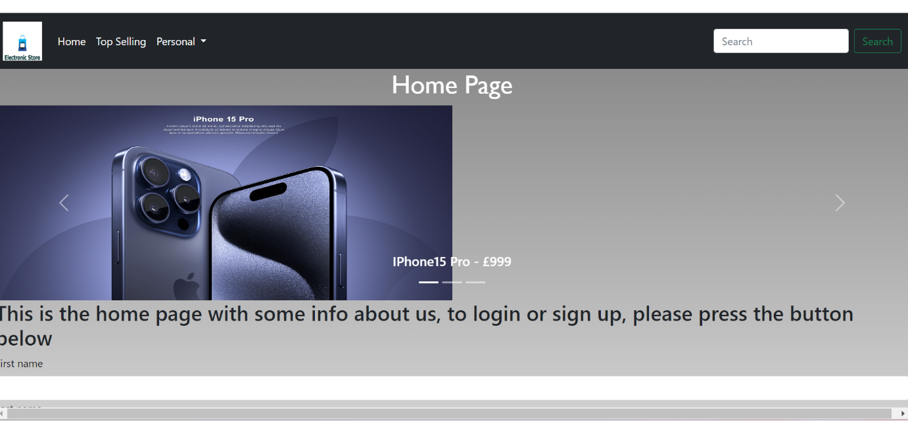
Test 2 – Another problem I encountered was with the slideshow not being aligned in the centre of the page.
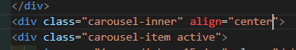
In order to fix this, I added the “align center” attribute

